# Lab – 1a Object and Class

Tasks:

1. (a) Create a class Circle that has an attribute **radius** equals to 0 and a method called **find_area(self)** that calculate and return the area of that circle.

Circle

radius : float

find_area (self) : float

Answer:

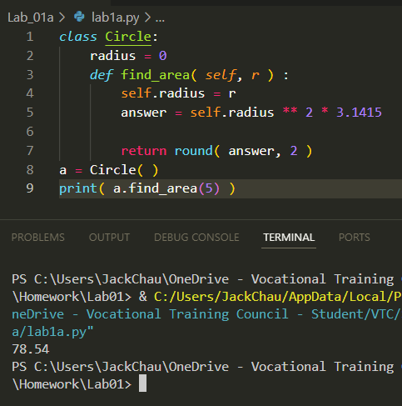

(b) Complete the client / driver program that will do the following:

1. Create three circle objects (c1, c2 and c3)
2. Set the radius c1 to 3
3. Set the radius c2 to 4
4. Set the radius c3 to 5
5. Find and total area of three circles (this have been done for you)

|  |
| --- |
| if __name__=="__main__":  #complete part 1 - 4 here  #you are not allowed to modify the following code  print (f"The total area of three circles is "  f"{c1.find_area()+c2.find_area()+c3.find_area():.2f}") |

Sample Output:

The total area of three circles is 157.08

Answer:

1. Correct the following program by enforcing data encapsulation of the attribute **age**. If the inputted age is invalid, print an error message “Invalid age:<age>, reset it to 18” where <age> is the inputted age, and reset the **age** to 18.

|  |
| --- |
| class Student:  def set_name(self, name):  self.__name = name  def get_name(self):  return self.__name  if __name__=="__main__":  stud1 = Student()  stud1.set_name("Chan Tai Man")  stud1.age = 19  print (f"Student: name={stud1.get_name()}, age={stud1.age}")  stud2 = Student()  stud2.set_name("Ng Hing")  stud2.age = -23  print (f"Student: name={stud2.get_name()}, age={stud2.age}") |

Sample Output:

Student: name=Chan Tai Man, age=19

Invalid age:-23, reset it to 18

Student: name=Ng Hing, age=18

Answer:

